Column ‘C’ bug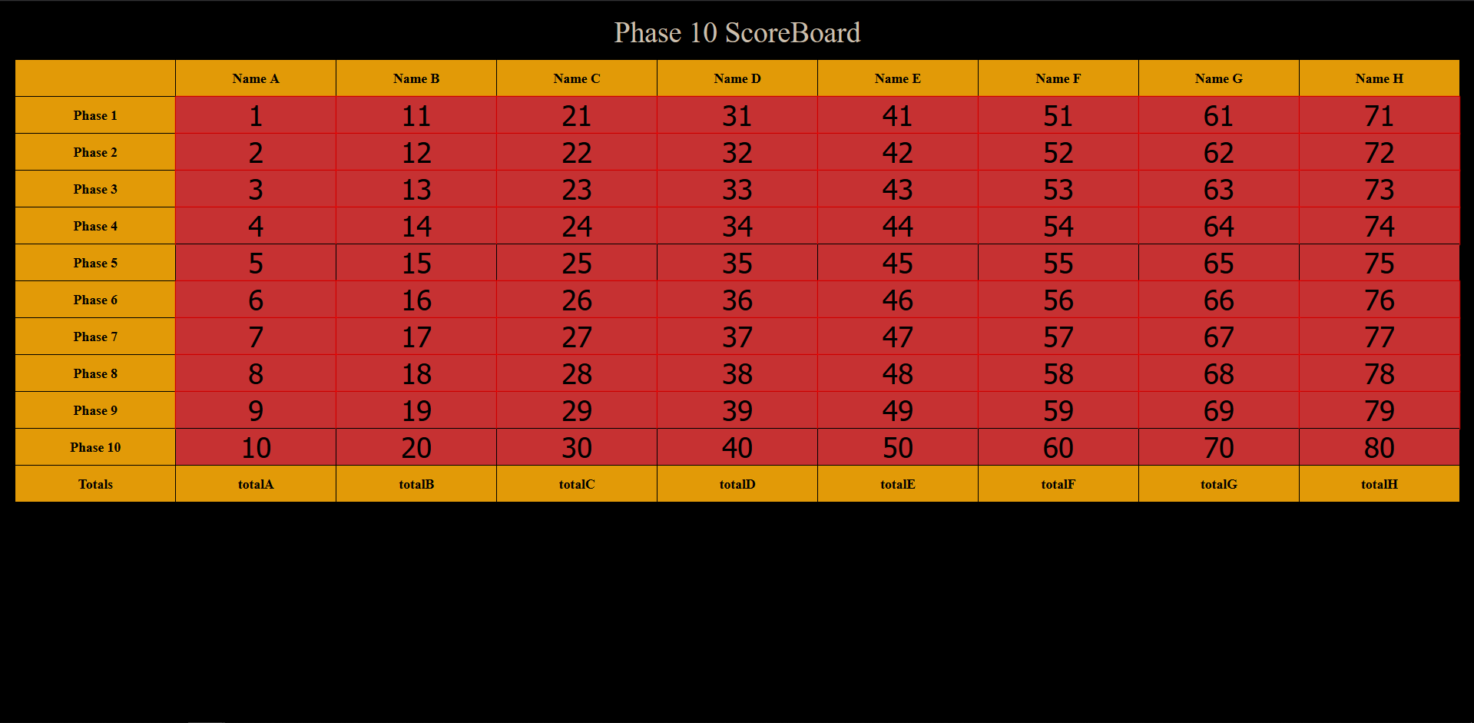

I had an error where I couldn’t read any value in column “C”. I put a unique value into every cell and printed out the value of every cell to demonstrate.

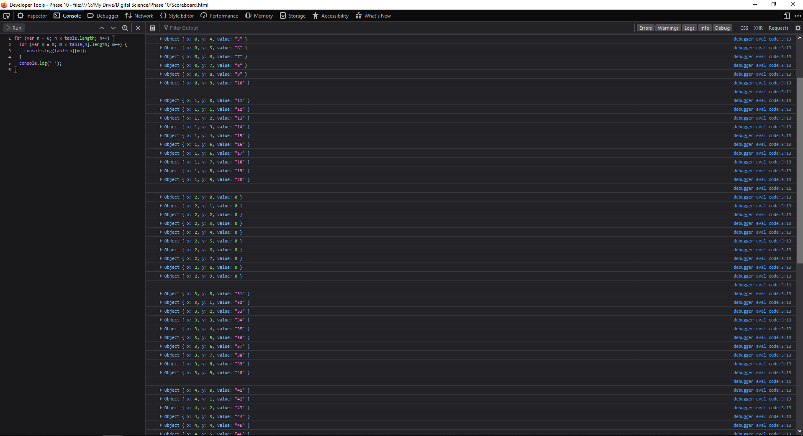

I discovered that in my HTML the IDs for all of the column C elements had a lowercase ‘c’ rather than a capital. I replaced all of the ‘c’s and it worked

NaN bug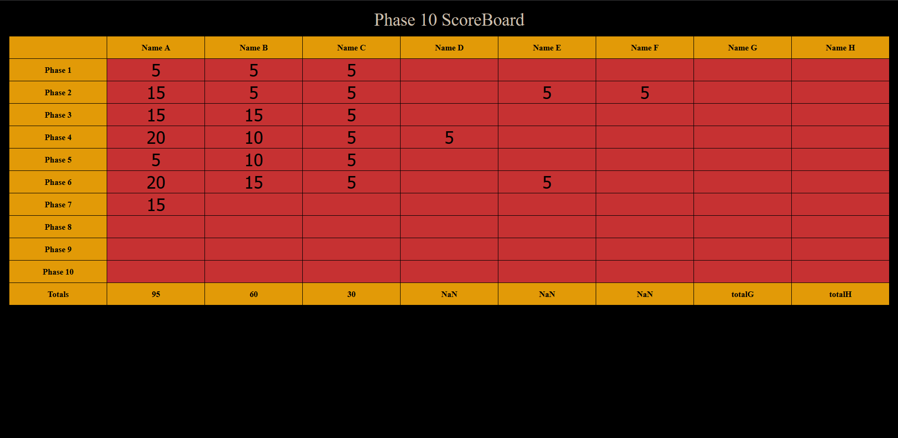

I had an error where if an empty cell was left above a filled cell the total was not a number.

TypeError: elmnt is null

I received a type error when running the above code.

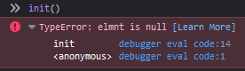

I was told the error was with the line if (elmnt.value == null), I figured it was because the line 'cell_'+String.fromCharCode(X+65)+String(Y+1) was not generating the correct string, making then line document.getElementById(elmntStr) not actually return an element object. I tested it out by running the code block below



This worked exactly as expected meaning that the code creating the ID string was doing the right thing. The problem had to be elsewhere

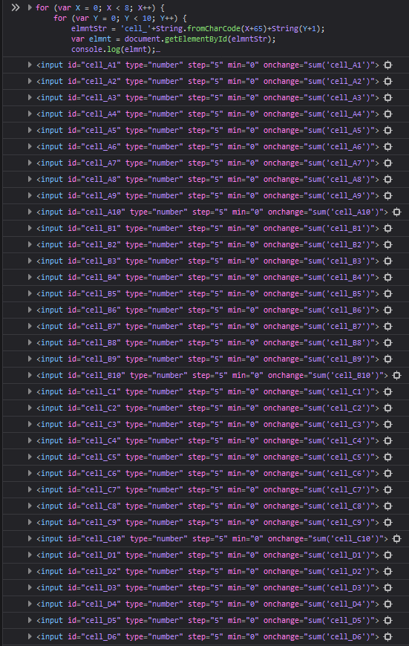



My next thought was that the HTML elements had not yet been created. As the script was being run in the head of the HTML, the body elements had not been processed at the script’s runtime.

I put the code into a function I called init and placed a function call to after the body element to ensure that the browser had processed the entire table.



This still did not fix the problem.

To figure out what else could possibly be causing the error I placed some console.log(); calls into the init function so I could trace where the error was



The first console output was ‘cell_ANaN’. This shows that the String.fromCharCode(X+65) was working as expected but String(Y+1) was returning NaN (Not a Number). It took some time but eventually I realised I had made a real klutz of a mistake. (Y+1) could not possibly be converted into a string if Y has not yet been defined. I had the line outside of the for loop which contained the declaration of Y. Simply moving the line inside of the for loop solved my problem.

My scoreboard now works exactly as expected.